**PROVISIONING PROFILE INSTRUCTIONS**

**INVITE NOTE:**

After accepting the invitation sent to you, if you are not able to login to the Apple Developer site (developer.apple.com), come find me and we’ll work on getting you fixed up. You need to be a member of the team before continuing on, so do not pass go from here. Come see me to get your “Get out of jail free” card.

**Add your Device to the Provisioning Portal in the Member Center**

Start Xcode

Open the Xcode Organizer (Command + Shift + 2)

Connect your iOS device to your computer. If iTunes starts up, go ahead and quit out of it (Command + q). Jump back into Xcode and wait for your device to be listed under ‘Devices’ in the right and pane of the Organizer. Select it by clicking on it.

In the main view of the Organzer, you should see an Identifier and a big alphanumeric GUID-looking string. Select the string and copy it (Command + c) or right-click > copy to copy the value to the clipboard.

Email the string to your Instructor and notify him/her that you have sent it. He or she will need to add the device to the portal if it hasn’t been added already. Once that has been done, the Instructor will notify you.

**Create a Certificate Request in the Provisioning Portal**

Open Safari and go to

<http://developer.apple.com/membercenter>

Login using the Apple ID you received the SoftSource Team invite for.

From the Developer Program Resources main page, navigate to “Certificates, Identifiers and Profiles”.

Navigate to “Certificates” under the “iOS Apps” category.

You will see a list of currently issued certificates. In the top right hand corner, there is a “+” button and a magnifying class button. Click on the “+” button to initiate a Certificate request.

**On the first screen in the “Intermediate Certificates” section, there is a link to download the Worldwide Developer Relations Certificate Authority Certificate. Download it now.**

Follow the rest of the prompts. If you get stuck on anything, grab the Instructor.

**You will be asked to generate a Certificate request using the Certificate Assistant in the Keychain Access Application**. The request will take the form of a file that you will need to upload to the Provisioning Portal as part of the Wizard’s steps. Follow these instructions exactly.

Once you have uploaded the Certificate Request, you should see your name in the list of Certificates with a status of “Pending” in red.

Once you have gotten this far, **notify your Instructor that your Certificate Request has been submitted**. The Instructor will then Approve it and advise you once it has been Approved.

Once Approved, refresh the main Certificates view that you should still be in within the Provisioning Portal. You should now see that your status in the “Expires” column has changed from “Pending” to a Date.

You should now be able to download an actual Certificate to install.

Click on the row with your name. It will expand to display a prompt to download your Certificate. Download it.

Go to the Downloads folder in the bottom right-hand corner of your Dock, or navigate to it from Quicksilver by typing control+space and start typing Downloads in the Quicksilver dialog. As soon as soon as it appears, hit enter and it will navigate you directly to it in the Finder.

Double click on the Worldwide Developer Relations Certificate Authority Certificate you downloaded earlier and the personal Certificate you just downloaded.

**Add Our Apple ID Account in Xcode**

Start Xcode.

Choose Xcode > Preferences.

Click Accounts at the top of the window.

Click the Add button (+) in the lower-left corner.

Choose Add Apple ID from the pop-up menu.

Enter your Apple ID and password, and click Add:

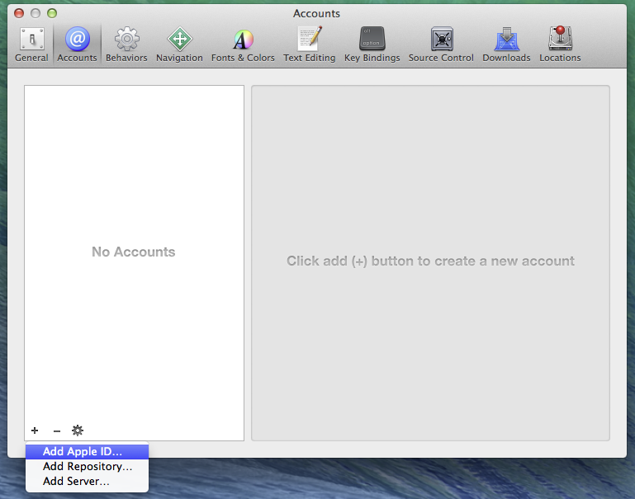

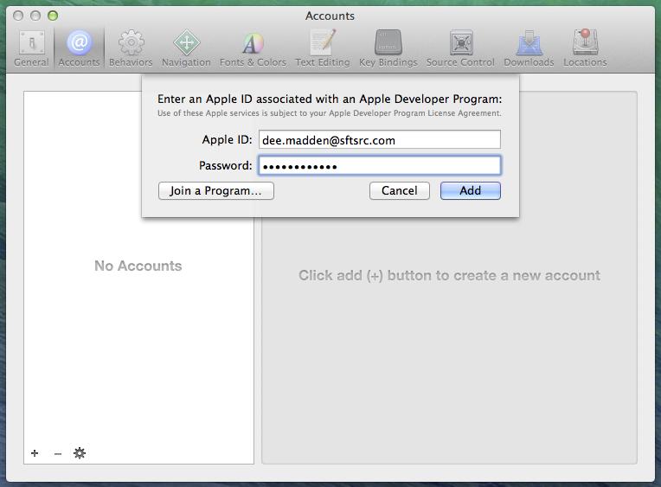

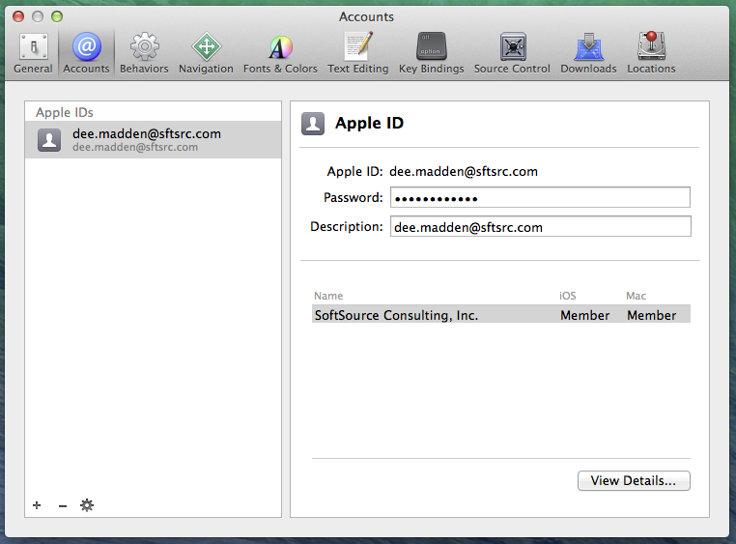

**Request Certificates with Xcode**

From the same Accounts section in Preferences, click on the “View Details…” button

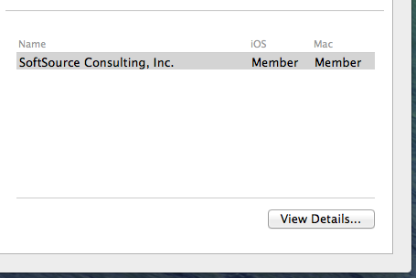

You will be presented with a dialog that shows all of your certifications (box at the top) and the provisioning profiles (box at the bottom) available to you. The dialog should look like the one below, with an iOS Development signing identity at the minimum.

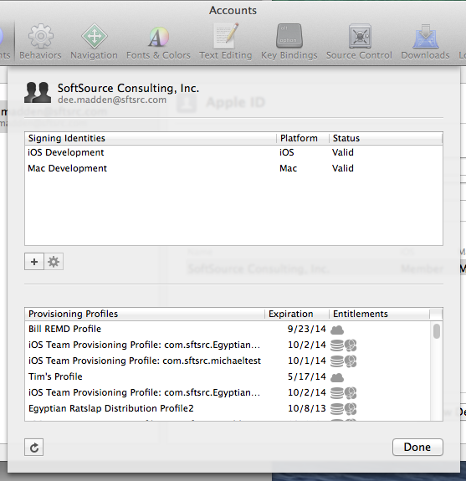

You’re real close to being bonafide now, but not quite. The next step is to get a provisioning profile on to your device.

**Get an ad hoc provisioning profile**

**Notify the Instructor that you’re ready to install a Provisioning Profile.** He or She will need to add you and your device to the master profile you are about to add.

At [http://developer.apple.com](http://developer.apple.com/), click **Member Center.**

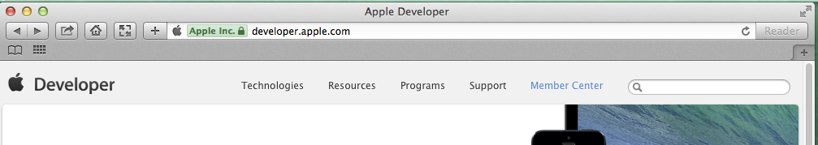

Around the middle of the page, click "Manage your certificates, app IDs, devices, and provisioning profiles."

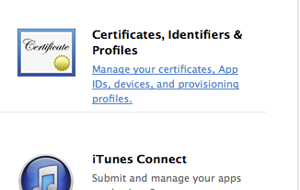

On the left, under iOS Apps, click **Provisioning Profiles.**

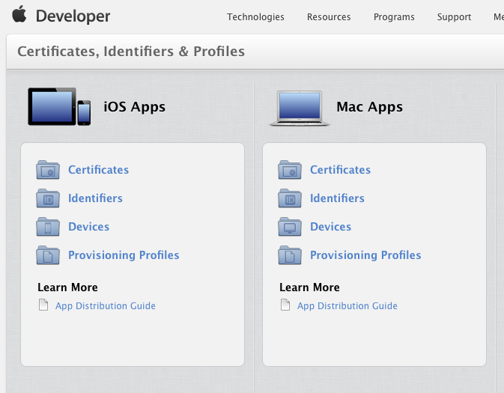

On the left side of the new page, under Provisioning Profiles, click **Development** or **All.**

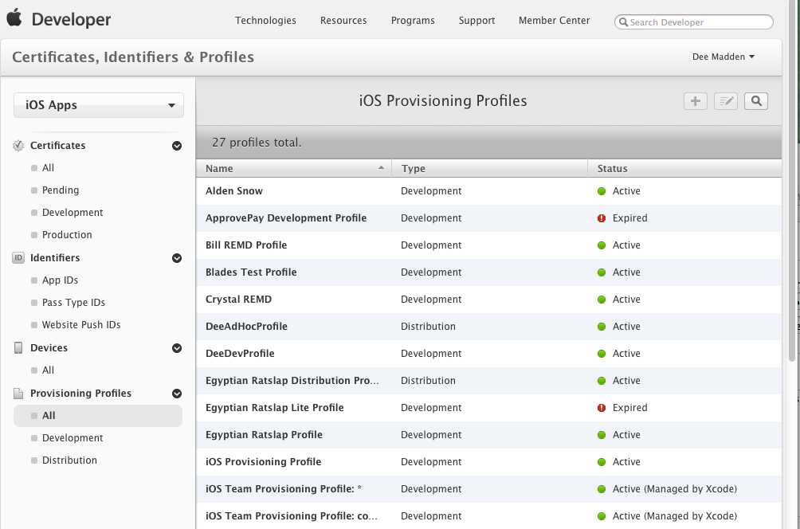

Find the profile named “iOS Provisioning Profile”.

This is a special profile with a wildcarded bundle identifier, allowing you to create and build as many projects as you want without having to bake a new provisioning profile for each one, which is something you would have to do in most real-world situations. For the purposes of this class, we’re going to bypass that step and have you use this one.

Once you find it, click on it and then click on the Download button:

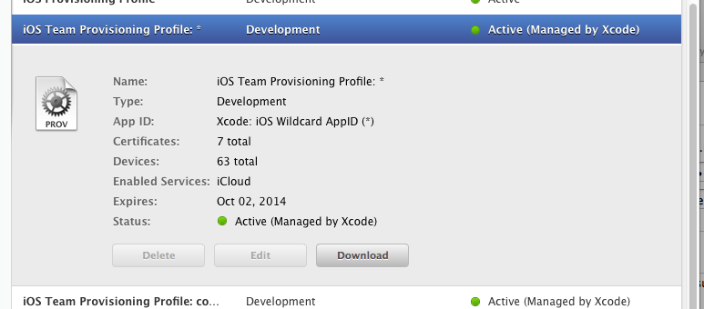

a .mobileprovision file will get dumped into your Downloads folder.

Now, connect your device to your classroom Mac if you haven’t already, and open the Xcode Organizer. Go to Window > Organizer:

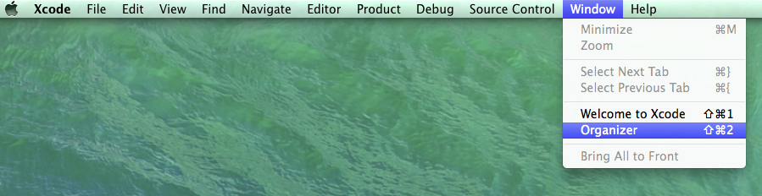

Once in the Organizer window you should see your device connected in the left hand pane. Click on “Devices” at the top and Click on the “Provisioning Profiles” option underneath your device. Your window should now look like so:

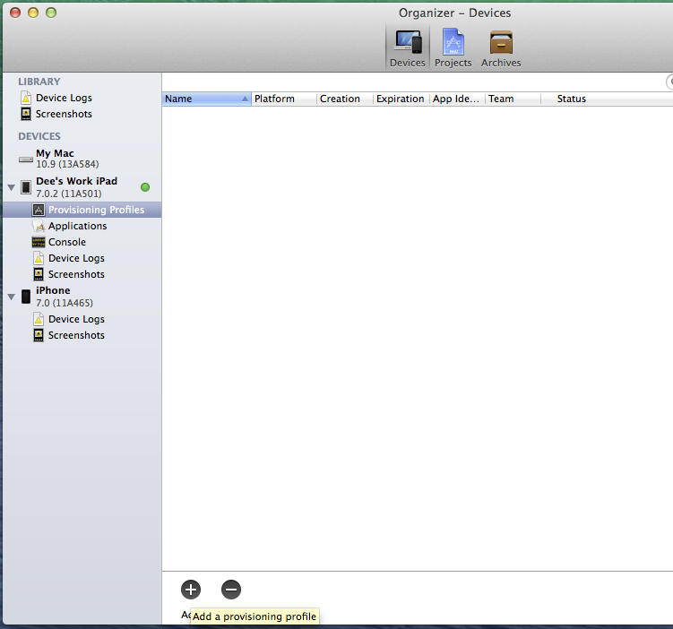

Click on the Add button at the bottom of the window. You will then be prompted to locate the .mobileprovision file you downloaded:

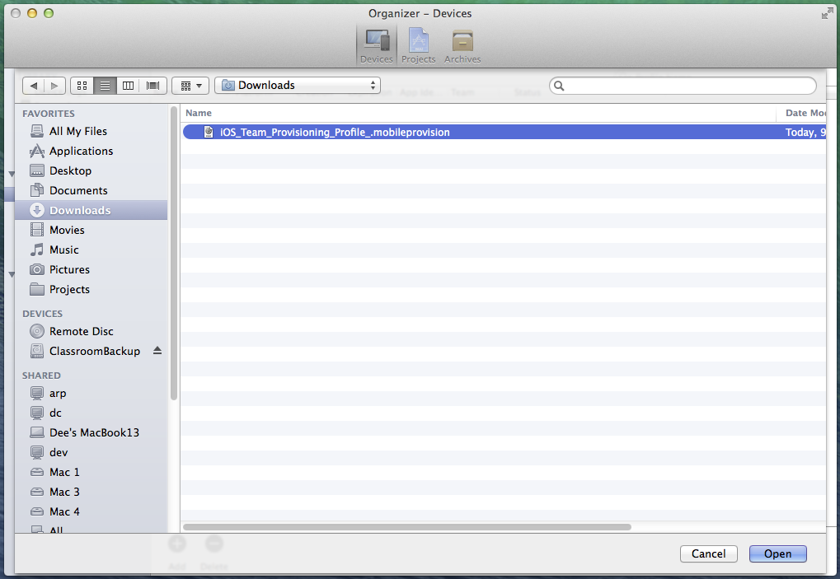

Once it has been opened, your Organizer dialog should look like this:

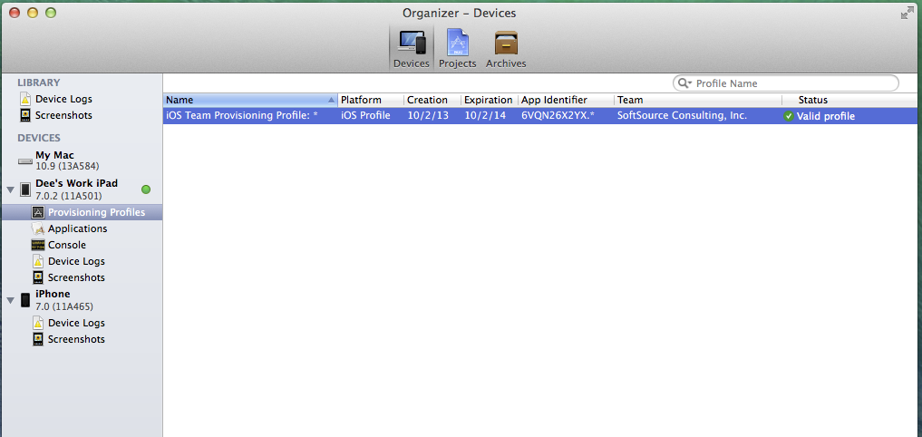

Your profile should display with a status of “Valid profile”, like the one above.

This means you’re good to go. You can now debug projects on your device, and you can build .ipa packages for over-the-air deployment or submission to the App Store later.

**IF YOUR PROFILE STATUS IS “INVALID” AFTER IMPORT –**

1. Try deleting the profile, disconnecting and reconnecting your device, and re-importing the profile.
2. If re-importing the file doesn’t work, try navigating into the Downloads folder and double-clicking on the .mobileprovision file. Go back and check the Organizer to see if it has been added. It should look like the screenshot above.
3. If the above does not work, Notify your Instructor. The profile sometimes needs to be re-generated in the portal in order to reflect that you have been added to it.

You should now see a green light next to your device in the organizer. If you see a greyed out circle, it means your device still needs to be set to developer mode. Click on the device in the left-hand pane of the Organizer to select it. You should now see a Developer Mode button in the left-hand pane. Click on it to turn Developer mode on in your device.

If the status light next to your device in Xcode Organizer turns Yellow and never goes green, try disconnecting and reconnecting your device. That should correct the problem. If it doesn’t, let your Instructor know.

Once the status light is green and you have a valid profile, you should be good to go!